Project Silence

Goal:

Features:

* Add/Edit/Delete an event
* Mute sounds during an event
* Send text message to person that called or texted you during an event
* Friends list to accept calls and texts from a particular person during an event
* Database to store events

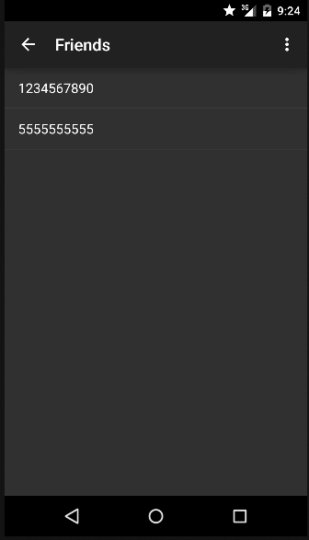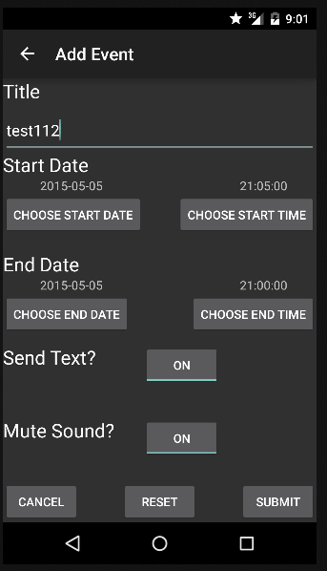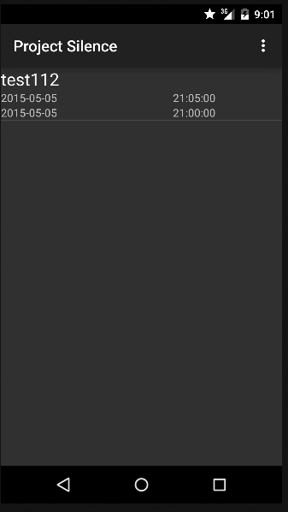Screenshots: